УДК 004.21
DOI:
Богусевич О.О.

BUILDING HIGHLY SCALABLE PARALLEL COMPUTE SYSTEMS WITH PARCS, KUBERNETES AND KEDA
This article presents the implementation and analysis of a highly scalable parallel system built on the Parallel Asynchronous Recursive Control System (PARCS) distributed computing framework. The study introduces a contemporary approach to handling ever-increasing resource demand by utilising the Kubernetes platform, KEDA integration, message brokers, and cloud-based scaling mechanisms. The built solution allows for seamless addition of computational resources, such as pods and nodes, to help PARCS solve parallelizable problems of any size. The article expands on the architectural and implementation details of the proposed system and provides an overview of similar tools in the field. It then demonstrates the solution's applicability by solving the Travelling Salesman Problem (TSP), an NP‑hard combinatorial optimisation, using a genetic algorithm. Experiments show substantial gains of the parallel implementation when compared to its sequential counterpart, with a speedup of up to 3.78 times.

Introduction
Parallelism in programming can be introduced in many ways, and PARCS, a universal add-on extension to the base programming languages that was first proposed in [1], is one of them. Its idea is to represent a complex parallel process as a set of execution activities that develop and communicate in a logically connected space called Control Space (CS). The activities, referred to as points, communicate exclusively through channels. They can also recursively create sub-spaces of any depth and evolve independently, thus forming a dynamically changing graph with points as vertices and edges as channels. Such a graph can appear in arbitrary forms depending on the configuration (see Fig. 1): a star, a tree, a cube, a ring, etc. Executed on the points, the actual workloads are defined by Algorithmic Modules (AM) – base-language programs extended with special commands, e.g. ‘Send data to channel’, ‘Accept data from channel’, ‘Create point’, ‘Delete point’, ‘Execute AM’, for interacting with CS. To write an AM, the interfaces need to be imported from an external PARCS library and referenced in the code.

Fig. 1. Ring and cube CS topologies

Over the years, support for PARCS has been added to many programming languages, including, but not limited to, Java, C, C++, C#, Python, Go, and Pascal. This paper aims to build on top of one of the .NET implementations, PARCS-Kubernetes in particular. While other PARCS variations had their benefits, only PARCS-Kubernetes was developed on a container orchestration platform, enabling the full exploitation of containerization — a common architectural pattern in distributed systems.
PARCS-Kubernetes, when compared to its predecessors, offers a wide range of powerful features, including automated deployment, granular scaling, robust resilience mechanisms, a graphical interface, disaster recovery, asynchronous processing, and more. However, its scaling model was imperfect, as it required human intervention: to deploy an additional pod, one had to modify the cluster definition and explicitly re-publish it. Thus, the complex processing of large-scale workloads, driven by constantly changing resource demands, would incur substantial manual overhead.
This paper aims to build on the foundations of PARCS-Kubernetes and address the shortcomings identified in the initial research. To achieve this goal, the following was implemented:
- Analyzing the previous developments in the field and systematizing the existing experience.
- Architecting and developing an extension to the existing solution using modern programming tools.
- Running extensive tests to verify the developed system’s effectiveness and compliance with the classical concept of PARCS.

Related work
PARCS-NET (2015) was the first .NET implementation of PARCS for the Microsoft-owned framework. Initially, it comprised a single-threaded host and a few TCP workers. Its initial, barely scalable setup required manual copying of executables across virtual machines on a private network. Although it was Azure-oriented at first, support for AWS and Google Cloud was later added. The deployment model had also evolved, as later versions introduced VM Scale Sets and containers.
PARCS-WCF (2021) used Windows Communication Foundation (WCF) for data exchange between the host and the daemons. The framework allowed extending the communication protocols, so dynamic protocol switching was implemented. Besides, it had improvements around security and threading, but the deployment model proved intricate, as WCF was already deemed obsolete back then and thus lacked cloud integrations.
PARCS-Kubernetes (2023) is the latest achievement in the PARCS ecosystem developed using the newest .NET 8 framework. It brings together containers and Kubernetes, enabling managed orchestration of workloads with robust load balancing, progressive deployment, disaster recovery, availability zones, transmission abstractions, service discovery, automatic scaling, production-ready resilience, and more. Since the proceedings of this paper are focused on extending this version of the platform, its former architecture needs to be elaborated on.
PARCS-Kubernetes original design suggested the following service components:
- Host – a CS orchestrator that serves as an entry point into the system.
  - ASP.NET Core Web API
- Daemon – an execution unit that handles the actual workload.
  - ASP.NET Core Console Application
- Storage – a store for unstructured data like input files and logs.
  - Blob Storage
- Database – a store for relational data like user profiles, jobs and statuses.
  - PostgreSQL
- Portal – a graphical user interface for managing AMs and jobs.
  - ASP.NET Core Blazor
A typical flow in the system would start with the development of an AM: a user would create a class library project, install the Parcs.Net library, and provide several problem-specific implementations of the IModule interface. They would then build the solution and paste the compiled binaries into the ‘Create module’ Portal view. Having successfully created a module, the user would select it from the list and navigate to the jobs tab, where they would be able to configure input parameters and run a new job. This would asynchronously pass the execution to the host through an API request and leave the user waiting for a result. The host would then discover available daemons using DNS resolution and orchestrate the AM over TCP connections with the daemons. Once all results are collected, the host would close the connections, update the job's status, and trigger a refresh of the job’s page on the Portal using web sockets.
One pitfall of this architecture was that if the user requests computations to be spread across K points, where K exceeds the number of available daemons, some daemons might become overloaded, leading to out-of-memory exceptions and delays in processing. To some extent, this could be addressed by allocating the necessary daemons in advance. Still, it is unlikely to be viable in the long term, as computational requirements vary from one job to another.

Proposed design
All things considered, in the forthcoming research, it was decided to focus on addressing the issue described, as its importance was evident. Providentially, Kubernetes provides strong support for automated horizontal scaling. However, in the basic configuration with Horizontal Pod Autoscaler (HPA), it only accounts for infrastructure metrics such as CPU and memory consumption, which may not be sufficient on their own to meet the requirements. This is because in PARCS, by the time a daemon has reached CPU/Memory limits, it is too late to provision an additional pod, as it has already notified the parent point that it has accepted the delegated unit of work. Unless an overheated daemon has access to its infrastructure metrics, it will not be able to tell whether it is about to crash and persist or pass the processing results to another pod in time. Resubmitting the failed transaction to a new pod in place of the crashed one was an option, but doing so would mean losing partial results and would still require the parent point to wait for the new one to be deployed. Instead, it was suggested that each time PARCS requested a point, an idle daemon would be provisioned to host it. If there was no such daemon at the time of the request, a new daemon pod would be deployed to satisfy the request, thus ensuring that no daemon shares two points. Additionally, when the sum of CPU and memory requested by the pods, which is defined for each pod individually, exceeded the capacity of the cluster, the node pool would be extended with a new VM instance. As for scaling down, when an AM finished processing and no longer needed the points it had created, it would dispose of them, thereby indicating to the cluster provisioner that the pods could be decommissioned.
The above was implemented using Kubernetes-based Event-Driven Autoscaler (KEDA) and Azure Kubernetes Cluster Autoscaler (AKS CA).
The former is a native Kubernetes extension to HPA that allows scaling pods up and down based on external triggers such as events, messages, logs, and database updates. Its example use cases include scaling a deployment up during a spike in API requests, when the length of an image processing queue increases, or when an application throws a few out-of-memory exceptions within several minutes. On Azure, it integrates with Application Insights, Blob Storage, Data Explorer, Event Hubs, Log Analytics, Monitor, Pipelines, Service Bus, Storage Queue and more. For the proposed architecture, KEDA was
Azure Kubernetes Cluster Autoscaler, on the other hand, is an AKS feature that allocates compute engines based on CPU/RAM availability. If a pending deployment pod requires more resources than available, a new node is automatically provisioned to the cluster. Conversely, when demand decreases and pods become idle, the surplus nodes are deallocated. To avoid overconsumption or cold starts, one can configure the lower, zero-inclusive, and upper bounds for the allowed number of virtual machines in a pool.
In conjunction with Service Bus, an Azure cloud-native message broker, the proposed scaling solution would take the following steps (see Fig. 2):
- The user initiates a new job that runs across three points.
- The portal calls the host to start the job.
- The host publishes three events to a “Point Requested” Service Bus queue, including the host machine address and job details.
- KEDA, which is configured to monitor this queue as an external scaling metric, detects the three messages and requests three Daemon pods, which are deployed as Kubernetes jobs, to be allocated.
- Daemon Pod 1 and Daemon Pod 2 start successfully. As they process their messages, each one switches to TCP mode and notifies the host that a point has been successfully created.
- At the time Daemon Pod 3 is scheduled for deployment, the overall requested RAM and CPU resources approach the cluster's limits, so AKS CA provisions a new virtual machine to handle the load.
- Once the virtual machine is successfully provisioned, Daemon Pod 3 starts, reads the last message from the queue, and connects to the host.
- The host spreads AM data across the points, collects the results, requests pods disposal and saves output to the database and filesystem.
- Daemon Pods receive the disposal commands, exit and thus trigger their own pods’ disposal, per the short-lived nature of Kubernetes jobs.
- AKS CA identifies decreased load within the cluster and unschedules the node it deployed before.

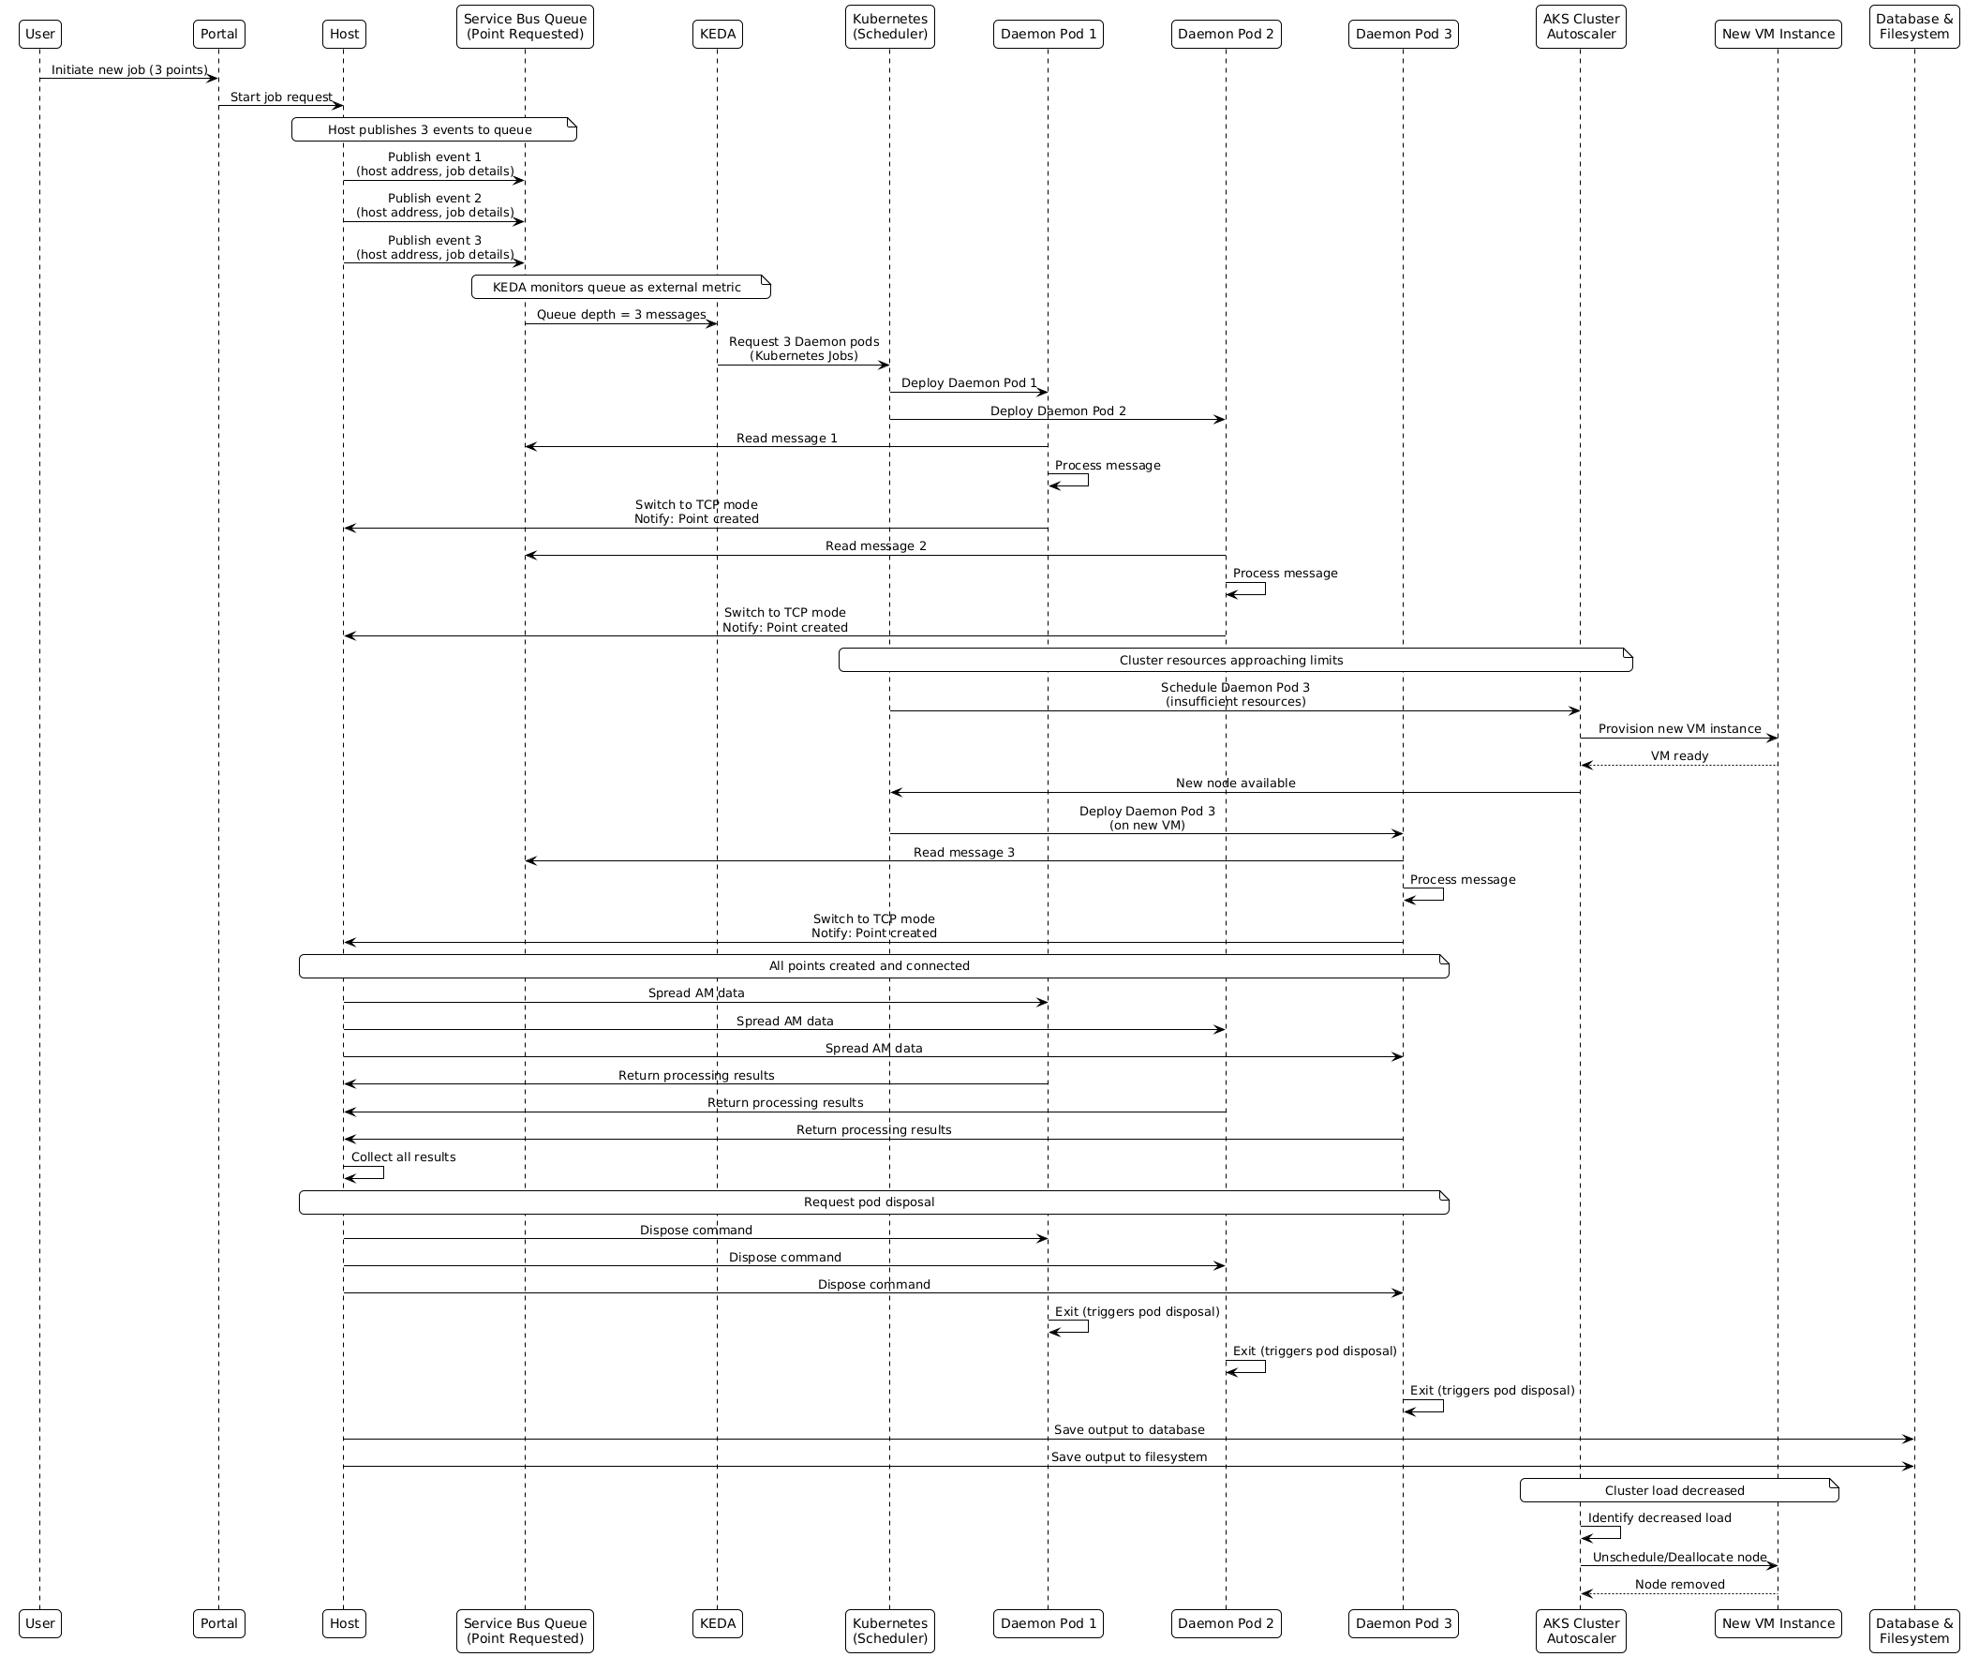
Fig. 2. Automatic scaling
This design extrapolated the original PARCS concept to the infrastructural level, allowing dynamic cluster expansion, where points map directly to pods, and requesting a new point is effectively the same as requesting a new pod. With this setup, it is enough to configure the solution once, and any task, no matter its size, can be solved.

